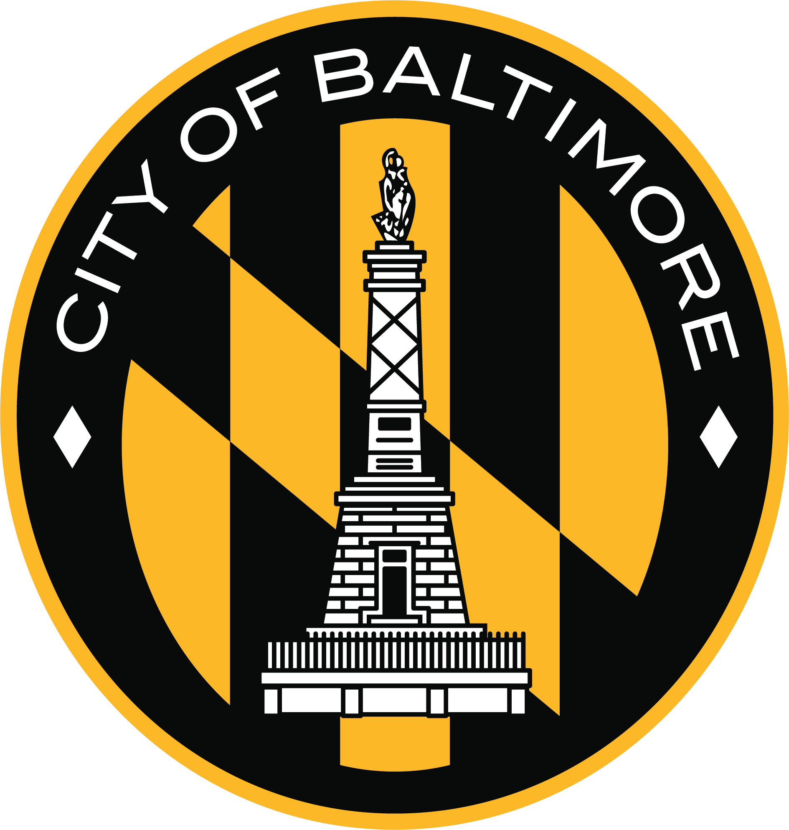

CITY OF BALTIMORE
DEPARTMENT OF TRANSPORTATION
Right of Way Services Division
Special Events and Street Vendors Section
The Councilman Harry S. Cummings Building
401 East Fayette Street, Lobby
Baltimore, MD 21202

APPLICATION FOR CITY SERVICES AND EQUIPMENT

- Application fees are listed on the City Services Checklist and are nonrefundable.
- If your event date does not meet the four week deadline, please verify if the services are available before submitting this form (Contact the Dept. of Transportation at 410-396-3909 regarding city equipment).
- Nonprofits must provide proof of status.
- Organizers of large and new events are encouraged to attend ICE meeting.

Event name:
Date: Location:

Telephone: Fax:
Website:
Address:
Street City State Zip

Event organizer name:
Title:

Telephone: Fax: Cell Phone onsite during event hours:
Email Address:
Address:
Street City State Zip

□ Non-profit must attach copy of 501(c)3

OFFICE USE ONLY BELOW LINE

Date Rec’d: Application Fee: Event Fee: Security Deposit: Application#

The Department of Transportation holds CALM (City Agency Logistics Meetin) meetings to discuss and coordinate your event. All City agencies that may need to assist you in having a successful event will be in attendance. CALM meetings are typically for large events. However, any applicant may request a meeting. To request a meeting, please contact 410-396-1675 or 1916.
SPECIAL EVENTS FEE SCHEDULE

The following is a list of City services and fees related to Special Events. This document will be used to calculate and communicate the total cost of your event. Please note that not all services and fees will apply for every event. The City will work with you to determine the best plan for your event based on your input and the Departments’ expertise.

EQUIPMENT/SERVICE | FEE PER UNIT | UNITS ORDERED | TOTAL COST | NOTES ON COST
Special Events Application Fees
10 or more weeks prior | $80
8-10 weeks prior | $125
6-8 weeks prior | $250
Equipment Request Fee
8 or more weeks prior | $50.00
6-8 weeks prior | $65.00
4-6 weeks prior | $80.00
Fire Department
Fire Dept. special event Application fee | $45
Fire Dept. Tent Inspection fee  (tents over 200 Sq. Ft.) | $150
Fire Marshall attendance (hourly fee, minimum of 4 hours) | $45 |  |  | Hours to be determined by the Fire Department
Fire Medic- 2 people (hourly fee per member, min. of 4 hours) | $45 |  |  | Hours to be determined by the Fire Department
Mayor's Office
Mayor's Stage | $600
Mayor's Stage Delivery, Set-Up, Security (per hour) | $75 |  |  | Hours to be determined by the Mayor’s Office
Police
Security (per hour/per officer) | $65 and up |  |  | Hours to be determined by Police Department
Marked Police Vehicle (for mobile events) (per vehicle) | $56 |  |  | Number to be determined by Police Department
Recreation and Parks* Varies on park and event size
Rec and Parks Application Fee | Varies
Set-Up Days Fee (per day) | Varies
Event Days Fee (per day) | Varies

Solid Waste
EQUIPMENT/SERVICE | FEE PER UNIT | UNITS ORDERED | TOTAL COST | NOTES ON COST
Trash Cans 1-20 Receptacles | $200
Additional Receptacles (per can) | $5
Dumpsters (8 cubic yards) | $400
Roll-Offs (40 cubic Yards) | $700
Recycling Bins (only provided for large events where DPW staff present) | Free
Load Packer Crew (per hour rate) | $85.00 |  |  | Hours to be determined by Bureau of Solid Waste
Street Sweeper Crews (per hour rate) | $32.00 |  |  | Hours to be determined by Bureau of Solid Waste
Cleaning Crew (1 driver, 2 laborers, & 1 Supervisor per hour/crew) | $71.75 |  |  | Hours to be determined by Bureau of Solid Waste

Transportation Fees
EQUIPMENT/SERVICE | FEE PER UNIT | UNITS ORDERED | TOTAL COST | NOTES ON COST
10x10 Tents (includes sandbags) |  |  | - | 1st 10 tents are FREE if picked up by event organizers
10x15 Tents (includes sandbags) |  |  | - | 1st 10 tents are FREE if picked up by event organizers
Per Tent Charge for every tent ordered over 10 total | $50 |  |  | For example, if you order 40 tents, the first ten are free. Each of the next 30 tents cost $50 each, totaling $1500. To have the tents delivered and set-up by the City costs $500, (see 26-50 tents below) for a total of $2000.
Tent Delivery and Set-Up Charge (1-25 tents) | $250
Tent Delivery and Set-Up Charge (26- 50 tents) | $500
Tent Delivery and Set-Up Charge (50+ tents) | $1,000
Supply/Deliver Stages 8x8 | $250
Supply/Deliver Stages 12x12 | $250
Supply/Deliver Wooden Stages 16x16 | $325
Supply/Deliver Wooden Stages 18x24 | $400
Supply/Deliver Stage 30x40 (steel) | $4,000
Supply/Deliver Upright Panels4x8 | $50
Supply/Deliver Risers 4x8x6 high | $50
Bicycle Rack (minimum 10) (per 10 bike racks) | $150
Horizontal Banner Installation(per banner per 2 weeks) | $150 |  |  | The non-profit discount does not apply to this item

Transportation Electrical | FEE PER UNIT | UNITS ORDERED | TOTAL COST | NOTES ON COST
Gas Powered Generators- gas and refueling included (per day per generator) (minimum of 5) | $100 |  |  | The CIty will provide generators for all electricity needs except in rare cases where electrical wiring is required.
Electrical Connection Electrician (per hour per electrician) (min. of 4 hours) | $75 |  |  | The City switched from providing electrical services to providing generators as a cost savings to applicants and the City. For example, last year, a two-day event cost an applicant $11,000 for wiring. By switching to generators it will now cost $2,400 (12 generators for 2 days each). Hours to be determined by DoT.
Traffic Set-Up, Materials, Management (cones, saw horses, personnel etc.) | FEE PER UNIT | UNITS ORDERED | TOTAL COST | NOTES ON COST
Traffic Set-Up and Materials- Block party and Parking | 0
Traffic Set-Up and Materials - Festivals, Events in Parks (per event per day) | 250
Traffic Set-Up and Materials - Parades, Footraces | 1000
STEO during event (per hour per person) (minimum 4 hours) | $32.50
Portable Variable Message Sign | $200

